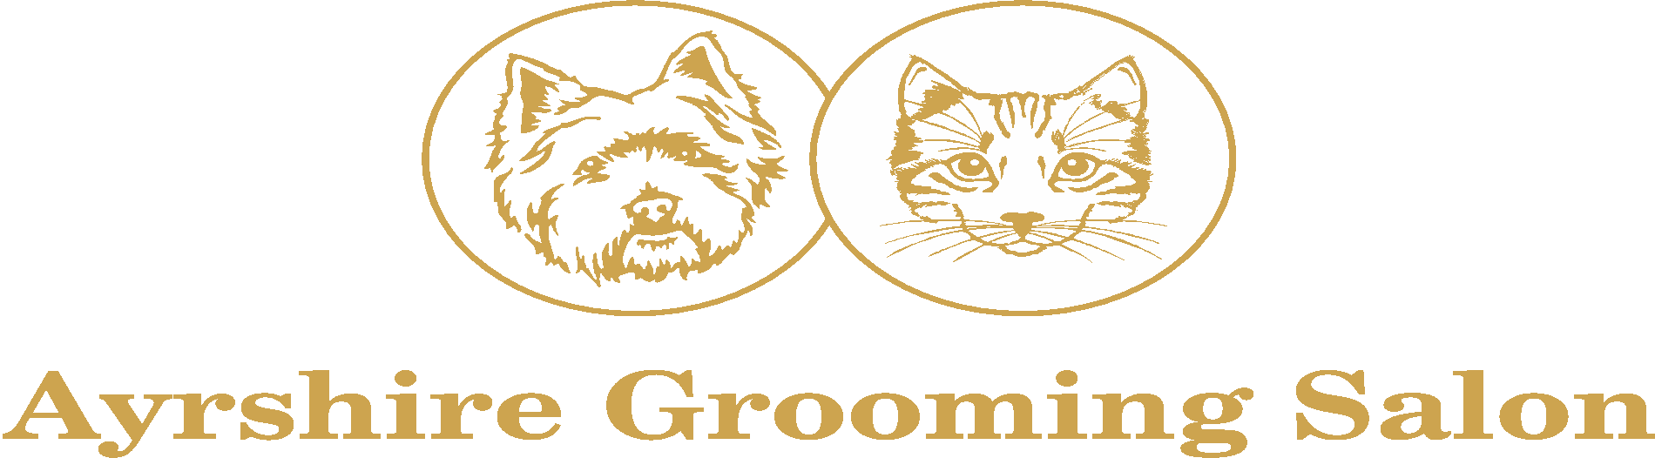

**CONTRACT OF TRAINING**

|  |  |
| --- | --- |
| Full Name: | (Mrs/Miss/Ms/Mr) |
| Address: |  |
|  |  |
| Postcode: |  |
| Contact Number: |  |
| Emergency Contact: | Mobile No: |
| Registration Number: |  |

Course Start Date: ________________________ End Date: _________________________

Please tick appropriate course:

|  |  |
| --- | --- |
| One Day Trial/Intro to Dog Grooming Course  Fee (£90) |  |
| 30 Day Training Course with Salon Certificate  Fee (£2,900) |  |
| Level 2 Certificate for the Dog Grooming Assistant (7863-02) 30 Days.  Fee £3,600 (Deposit £1,600) |  |
| Level 3 Diploma in Dog Grooming (7863-03) 40 days. Only available after completion of Level 2. Fee £3,900 (Deposit £1,900) |  |
| Combined Level 2 & 3 Dog Grooming, 70 days  Fee £5,700 (Deposit £1,700) |  |
| Private 1-1 Training  Fee £180 |  |
| Experienced Groomers Level 2&3, 15 days  Fee £2,600 |  |
| iPET Network Level 3 Diploma in Dog Grooming & Salon Management  (30-40 days) £4,850 |  |
| iPET Network Level 3 Certificate in Dog Grooming & Introduction to Styling  (15 days) £3,850 |  |
| iPET Network Level 3 Award in an Introduction to Dog Grooming  (5 days) £1,700 |  |
| iPET Network Level 3 Award in Canine Emergency First Aid  (One day) £150 |  |
| iPET Network Level 3 Diploma in Cat Grooming & Salon Management  (25 days) £4,995 |  |
| iPET Network Level 3 Certificate in Cat Grooming & Introduction to Styling  (10 days) £1,999 |  |
| iPET Network Level 3 Award in an Introduction to Cat Grooming  (5 days) £1,500 |  |
| iPET Network Award in Feline Emergency First Aid  (One day) £150 |  |

NB: Students may use their own equipment authorised by the Salon Owner, provided it is of suitable standard. However, they do so at their own risk. Ayrshire Grooming Salon accepts no responsibility for damage or loss of equipment, regardless of the cause.

**GENERAL TERMS & CONDITIONS:**

* All training will be given to Summit, City & Guilds and iPET Network standard.
* A deposit is required to secure your training date. Full payment is required 2 weeks prior to the commencement of the Course.
* Training times are **9.30am–5.30pm**. This may vary in order to meet the needs of the business. A 30minute lunch break must be deducted from training hours. There is a fridge, microwave and kettle available for use. Tea, coffee and bottled water are available.
* Once arranged/confirmed, course dates cannot be altered unless you can provide details of extenuating circumstances.
* You will be required to provide dates for training, ensuring sufficient notice is given.
* Once arranged/confirmed, you will be required to provide a minimum of 48hours notice if cancelling a date. Failure to provide the agreed notice will result in you ‘Buying Back’ the day(s). The ‘Buy Back’ rate is £100 per day.
* Any days missed due to sickness will be required to be rebooked and ‘Buy Back’ rate paid unless a medical certificate can be provided.
* All absences will be dealt with on an individual basis at the Business Owner/Manager’s discretion.
* Mobile phone use is prohibited during training. However, can be used for training/ photographic purposes, and only with the authorisation of the Business Owner/Manager. No personal calls or social media use is permitted during training hours.
* Any photos taken within the salon during training must not be shared on ANY social medial platforms.
* All iPET Network theory must be completed prior to commencing assessments.
* Both iPET Network and City & Guilds courses must be completed within a 12 month period, unless there are extenuating circumstances which must be discussed and authorised by the Salon Manager/Owner.
* Grooming tunics will be provided by Ayrshire Grooming Salon and must be worn during training.
* You will be expected to assist with end of day cleaning and you will also be required to clean all your equipment used.
* Any misuse or damage of equipment by you, may result in charges being incurred.
* Ayrshire Grooming Salon will not be held responsible for any loss or damage to personal possessions during training.

**HEALTH & SAFETY:**

* Any accidents or injuries during your training hours, must be reported to a member of staff at Ayrshire Grooming Salon and recorded in the Accident Book.
* It is your responsibility to ensure your Tetanus status is up to date.
* You must be fully aware of your Health & Safety Policy and procedures at Ayrshire Grooming Salon and agree to adhere to it prior to the course commencing. This is in our course pack.

**FIRE PROCEDURE:**

* There is one fire exit at the salon entrance.
* Once you have exited the building, turn left, and proceed to the Evacuation Assembly Point which is at the Car Park in Hill Street.
* Do not take any belongings with you, only the dog or cat you are working on, ensuring collar and lead is securely on the dog prior to leaving the building.

**CONDUCT:**

* You will be expected to conduct yourself in a civil/appropriate manner at all times throughout your training. Failure to do so may result in the termination of training.
* Loss of temper of any form or cruelty towards any animal will not be tolerated and will result in immediate termination of your training.
* A verbal warning may be issued prior to the termination of your training, depending on the severity of your actions.

**REFUND POLICY:**

* Paying your deposit enters you into a contract with Ayrshire Grooming Salon. If you wish to cancel your course, you will have a 14 day ‘cooling off period’ (from the date Ayrshire Grooming Salon receives your deposit). After this time, your deposit will NOT be refunded.
* RIGHT TO CANCEL: You have the right to cancel this contract within 14 days without providing a reason. The cancellation period will expire after 14 days of Ayrshire Grooming Salon receiving your deposit.
* To exercise the right to cancel, you MUST inform Pamela Campbell, Business Owner, Ayrshire Grooming Salon of your decision to cancel this contract by a clear statement, either by letter sent by post or email.
* If you decide to finish your training early, the course fee will not be refunded. However, under exceptional circumstances, it may be possible to rearrange a continuation of your training at a later date.

**COMPLAINTS & APPEALS PROCEDURE:**

All assessors and tutors associated with Summit and iPET Network are committed to delivering assessments and support in a prejudice free environment.

* If you feel that you have not had fair and equal access to support or assessments.
* If you can identify shortfalls in our quality assurance process.
* If you can identify standards that have not been met then it is in your own personal interest and that of the Pet Industry Federation and iPET Network that you report this to the Pet Industry Federation and IPet Network.

The following steps should be taken in order to make a complaint or appeal:

* Contact your named Assessor/Tutor, Pamela Campbell, Business Owner within 5 working days of your request. A mutually convenient time will be arranged to discuss the issue. At this point, you MUST identify your concerns/complaint and we will endeavour to assist you. If you are still not satisfied, then you should inform Pamela Campbell, Business Owner. Ayrshire Grooming Salon will then contact the Training Provider and their Quality Assurance Team (IQAC).
* The IQAC will acknowledge receipt of your written statement within 7 working days from receipt of your letter and identify when you can expect a response.
* IQAC will provide in writing their findings, making a copy to the training school within a further 7 days.

On receipt of these findings, if you are;

* Satisfied - Send a written letter to the IQAC to this effect, no further steps apply and the process ends.
* Not Satisfied - Send a written letter to the IQAC to this effect.
* IQAC will request the Training Provider advisor to contact you and attempt to resolve the issue within 7 working days.
* If the Training Provider cannot aid the complaint, they will contact External Assurance, who will deal with the case from thereon.

Trainee Name: _______________________________

Signature: ___________________________________ Date: _____________________

Staff Name: __________________________________

Signature: ___________________________________ Date: _____________________